E-Voting System Report
Design and Implementation of a Digital Voting system

DEPARTMENT OF ELECTRONICS AND COMPUTER ENGINEERING
BY: BONIFACE KIMAIYO KIPCHIRCHIR
ENE212-0083/2024
ECE 2.2
OBJECT ORIENTED PROGRAMMING PROJECT

1. Introduction
In the contemporary era of digital transformation, traditional electoral processes face significant challenges regarding speed, accuracy, and transparency. This project presents a C++ based Digital Voting System designed to automate the elective process for multi-tier government positions, specifically targeting MCA, MP, and Governor seats.
The system serves as a technological solution to mitigate human error in tallying, prevent electoral fraud through 'one-man-one-vote' logic enforcement, and provide instantaneous statistical outcomes through algorithmic sorting. By leveraging Object-Oriented Programming (OOP), the system ensures that voters and candidates are handled as robust data objects with strictly defined attributes.

2. System Requirements

2.1 Functional Requirements
- Functional requirements define the core actions and behaviors of the system:
- Admin Authorization: A secure gatekeeping mechanism requiring a password (admin2026) to unlock system management features.
- Voter Registration & Management: An interface for administrators to create unique voter records containing identity documentation and polling station metadata.
- Identity Verification Protocol: A search-and-match algorithm that validates voter IDs against the internal database before granting access to the ballot.
- Electoral Integrity Logic: A state-tracking mechanism that utilizes boolean flags to ensure a voter cannot re-enter the voting loop once their ballot is submitted.
- Tiered Ballot Casting: Sequential voting cycles for MCA, Member of Parliament (MP), and Governor positions within a single session.
- Algorithmic Tallying: Use of the Standard Template Library (STL) sort algorithm to provide real-time winner determination based on vote counts.

2.2 Non-Functional Requirements
- Security & Access Control: Restricted access to sensitive data (results and registration) ensuring system integrity.
- Data Robustness: Implementation of input buffer clearing (cin.ignore) to handle non-standard string inputs without system crashes.
- Usability: A clean, menu-driven Command Line Interface (CLI) optimized for administrative and voter clarity.
- Scalability: An architecture capable of handling expanding candidate lists using dynamic vector containers.

3. System Architecture & Design
The system follows a Modular Monolithic Architecture, organized into three distinct logical layers:

3.1 Data Layer (Classes)
The data design utilizes Class Encapsulation and Composition. The 'Candidate' class contains an instance of the 'Party' struct, ensuring that political affiliation is intrinsically linked to the candidate data.
Class | Key Attributes | Role in System
Voter | Name, ID, Station, hasVoted | Identity tracking and eligibility enforcement.
Candidate | Name, Position, voteCount | Record of popularity and elective tier.
Party | Name, Symbol | Political context and branding for candidates.

3.2 Logic Flow
The voting logic employs a pointer-based verification system. Upon entering an ID, the system iterates through the voter vector. If a match is found, a pointer to that specific object is passed to the voting function. This allows direct modification of the 'hasVoted' status in memory, ensuring O(1) update efficiency once the voter is identified.

3.3 System Architecture Diagram
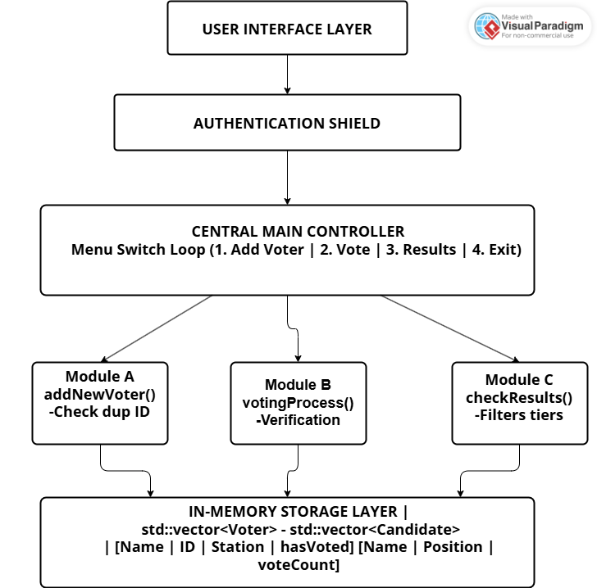

4. Output Terminal

4.1. Terminal Main menu(New voter registration)
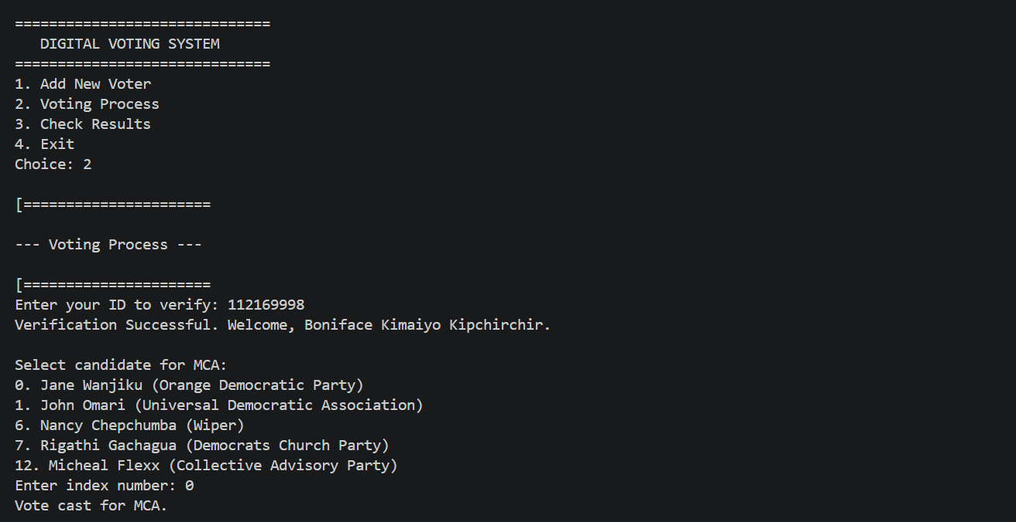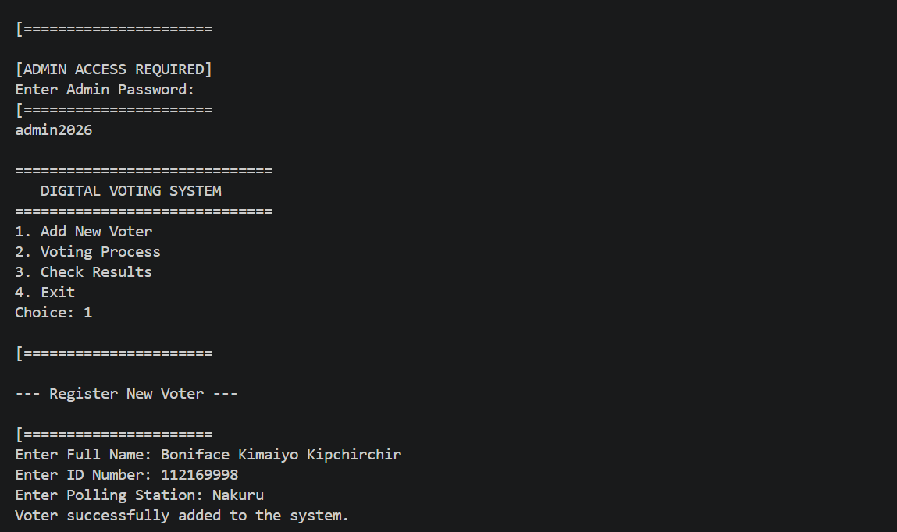

4.2. Voting Process (Voter 1 and Voter 2)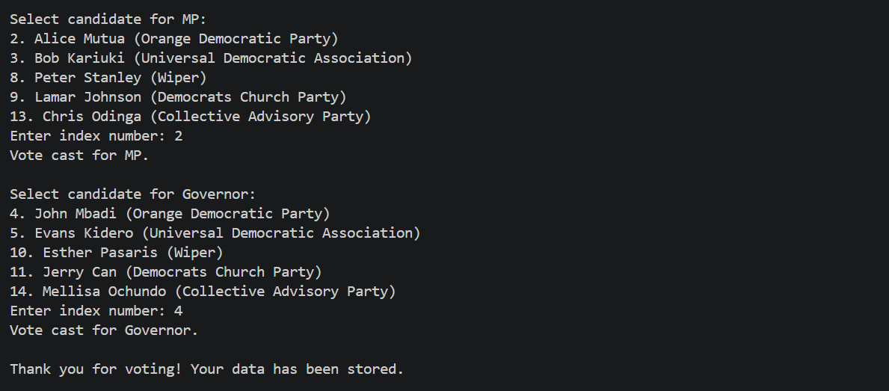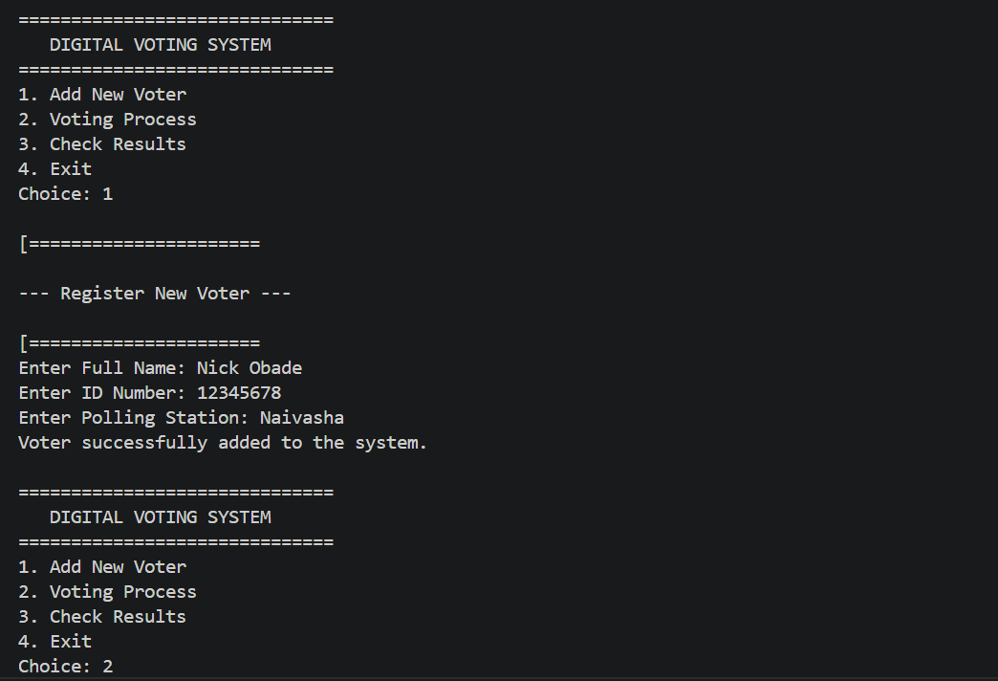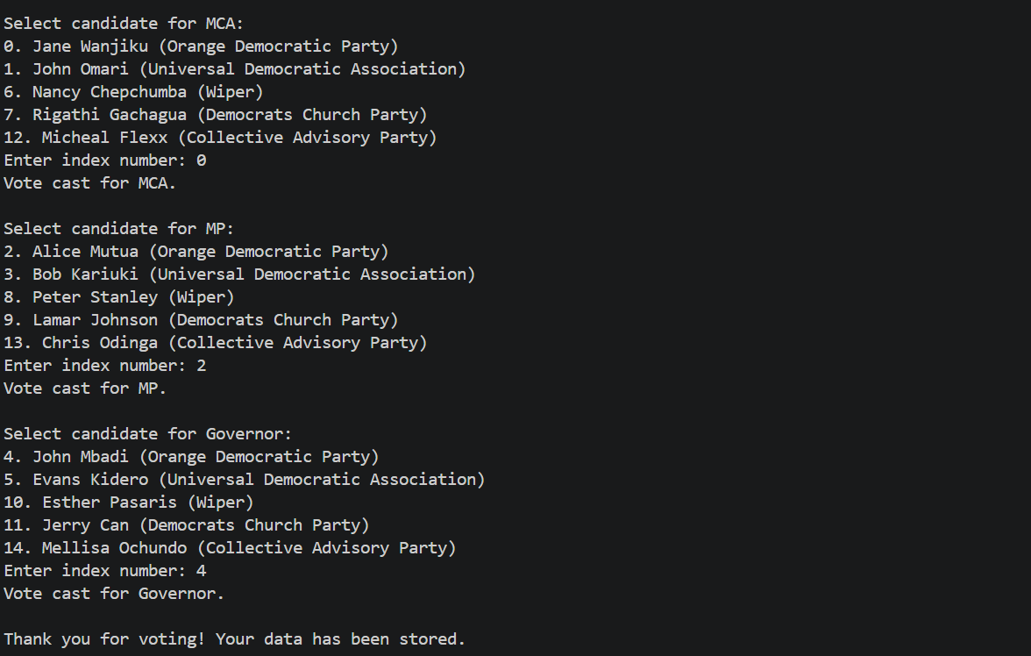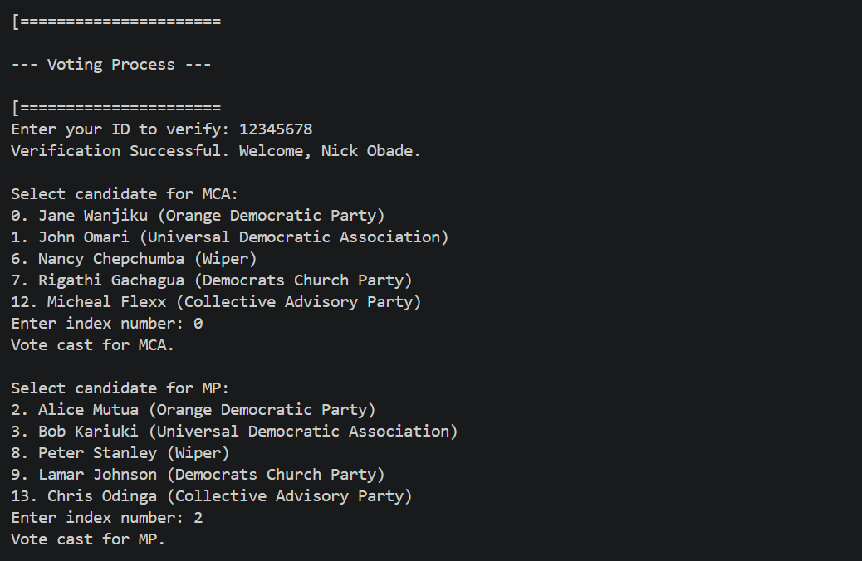 4.3. Voting Results 